

Process book

Does Lottery win people a fortune overnight?

Yuhan Su, Zoe Zhang

### 

### 

### Project Introduction:

Unemployment rate keeps rising during the global pandemic. Even though every government in the world is putting effort into changing the current situation, it still caused some economical problems. During this period of time, people might choose the fastest way to solve their financial issue. Lottery would be the best way, but is it truly winning people a fortune right away? We would love to gather the data and analyze the numbers and locations of Jackpot in the world.

Data from three regions will be represented in this visualization.

### 

### Project Proposal (Oct. 30th)

In the project proposal, we have settled the most important parts of our project, including the main topic and three general visual designs.

There are several qualitative questions we will explore during the whole project:

* What questions are we trying to answer?
* How did these questions evolve over the course of the project?
* What new questions did we consider in the course of your analysis?

Also, we assigned responsible parts to our team members. Yuhan is responsible for presentation in peer review, scheduling, Data-gathering; Zoe is responsible for website visual design, description, final presentation. The general idea is that we do everything together and decision-making is from the one responsible for a certain part.

(see the whole proposal in [CS 6630 Project Proposal_Team Lottery.docx](https://docs.google.com/document/d/1KiC9Zw2vHeLGsgX90SdK1PvLJl2pJAIGTRGnmEOkkjM/edit?usp=sharing))

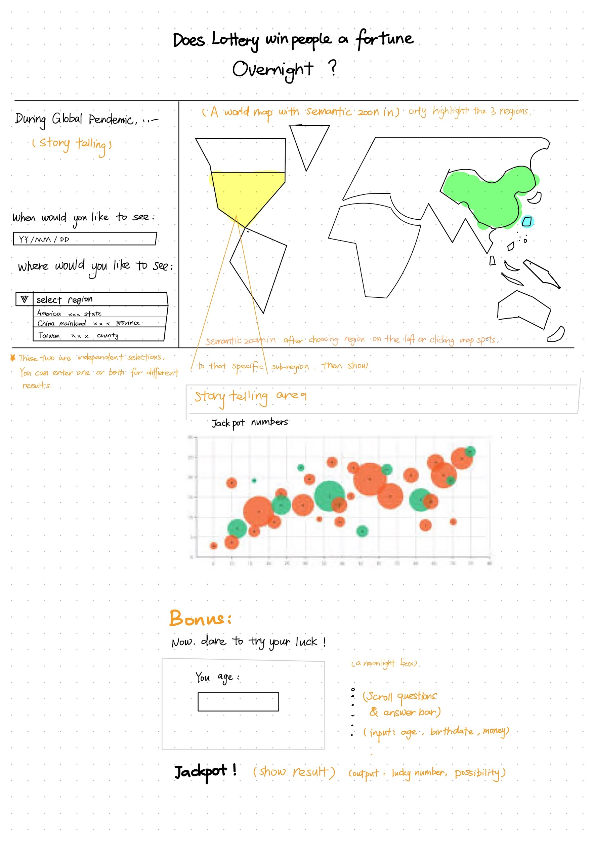

**Figure 1: Sketch of one visualization design**

### Peer review (Nov. 5th)

"Battery Electric Bus Deployment in the Greater Salt Lake Region" team is our peer group. During this session, we presented our general idea, datatype, visual design sketches and other basics to each other.

Our team found that the project of our peer group is rather professional, and is related to actual on-going social work. That leaves us in a really opposite place, that is more entertaining and is easier for the audience to understand our goal.

* **Written record of peer review session:**

**Our project name:** Does Lottery win people a fortune overnight?

**Member:** Yuhan Su, Zoe Zhang

**Peer’s project name:** Battery Electric Bus Deployment in the Greater Salt Lake Region

**Member:** Yinhu Wang, Yirong Zhou

#### Question from Peers:

*From Yinhu:*

Q: What is the reference of the prediction part?

A: We would love to do more analysis and prediction, but the personal buying information is confidential. Therefore, we change it to give users a random number function.

Suggestion: You can show more detail in the map

A: Yes, as the mouse is over the map, the location and the lottery detail will be shown in the information box.

Q: Does the map provide the related information when zooming in/ out?

A: Yes, we will do that.

Q: If multiple views, are they coordinated?

A: Yes, we provide a map and the statistical graph to show the data about the location. It is coordinated.

*From Yirong:*

Q: Do you provide animation?

A: Yes. As the mouse moves, the statistical graph will have animation.

Q: Do you have enough data?

A: Yes. The amount of data depends on the public information we can retrieve. Because each location’s data differs in administrative areas, years range. Fortunately, it is quite enough to visualize the data.

Q: What kind of interaction do you provide?

A: Click the location and give the corresponding data.

Q: Are the objectives interesting to the target audiences?

A: Yes, we target people who like the lottery and we will provide the information about jackpot.

#### Questions from us:

Q: What triggered you to do this project?

A: It is an on-going project fund by UTA. Analysis of this project will be directly used to optimize BEB.

Q: You provide 3 examples with different budgets, why do you want to do that? Is that meaningful?

A: The 3 examples are not special, just showing what users can do with the budget option. Users of this website can select dozens of different budgets to see how it performs in the result.

Q: If multiple views, are they coordinated?

A: Yes, they are coordinated. The left view will show the deployment from a whole perspective while the right view will show the route in detail on which the bus is replaced with BEB by clicking the bus route on the left view.

Q: Is there any animation?

A: Yes, animation will be used for the graphics.

Q: PM 2.5 seems like a proper indicator for pollutants. But is unemployment an suitable indicator for the financial situation of the residents?

A: Yes, we use unemployment as an indicator for the financial situation of residents in a region. And the unemployment data is just one column of the whole data set. Another related data is the income data of residents. Through mining these data, we find that regions with worse pollution problem usually have more low-income residents and higher unemployment.

#### Suggestions from us:

1. There are some abbreviations that are hardly understood such as the words below when browsing the web for the first time. It is probably better to provide some instruction or some information to those words.

Ex: UTA(Utah Transit agency), BEB (Battery electric bus), TAZ level (unit name, traffic analysis zone)

1. Probably you could apply the animation-scroll on the map of SLC. By doing scroll up/down, applying pollutant/financial condition on the map.

### 

### Project Milestone(Nov. 1th)

We have been working on the questions that our peer group introduced based on our proposal.

#### Project mentor feedback on proposal (Nov. 13th):

Our project mentor has released her commit and suggestions upon the proposal. She said and I quote here:

“I like the topic, and I think your design is really interesting. I like the third design, which is clean and concrete. But I think my question is that do we really need a world map here? I didn't see any analysis across countries that requires the location of each country, so maybe only display the map of the selected country? Also, it would be great to have some charts reflecting some statistics of the lottery data, e.g. how does the probability change overtime? What if we want to compare the probability between two or more regions? That might be more convincing to tell people to stay away from gambling by showing how the probability always is small over time/ across regions :-) Overall, good job!”

We’d like to specify the questions:

Q: Do we really need a world map here? I didn't see any analysis across countries that requires the location of each country, so maybe only display the map of the selected country?

A: Yes, as pictured in the beginning, even though we only collect datas from three regions for the visualization, still, datas from other interesting regions can be applied to our visualization if we are going to continue our work and put it to actual use. Like, helping police with education people to get away from gambling. And we are actually planning on cross-mining numbers among different regions in the story-telling part.

Q: It would be great to have some charts reflecting some statistics of the lottery data, e.g. how does the probability change overtime? What if we want to compare the probability between two or more regions? That might be more convincing to tell people to stay away from gambling by showing how the probability always is small over time/ across regions.

A: We only thought about displaying the possibilities in 1-dimension. But your suggestion provides us some new insights and we will look into it in the upcoming week.

#### Progress so far (Nov. 15th):

We watched over 20 different visualizations online, studied their visual design and storytelling.

Evaluated problems and suggestions from peer group.

Address some changes based on the peer review session.

Data has been collected systematically.

We started coding the frame and uploaded the framework on [our github page](https://github.com/yuhansu615/dataviscourse-pr-DoesLotterywinpeopleafortuneovernight).

#### More changes:

Simplify the design. We were planning many zoom in/ out and gesture interactions in the beginning . But after studying visualizations online, we have decided to optimize animations and interactions by cutting some of non-necessary designs from the prototype.

Multi-dimensional visualization of analysis. We are trying to add more “cross-region” & “cross-time” comparison along with storytelling, in order to provide alternative ways for the audience to understand more about our intention.